Module 2: Communicating Insights, Dashboarding and Data Storytelling
Weekly Assignment 1
Objective:
To find top 3 regions that are contributing to Melbourne real estate sales and by analysing Monthly sales to recommend which region to focus for expansion.
Data conversion :
In given excel file : Melbourne Real Estate.xlsx, Date column values are converted from General type to Date.
(Ex: ‘42404’ to ‘4/2/2016’)
Vizualitation Charts:
1.Pie chart : To visualise Percentage of Sales amount by Regions.
Fields used :
Categorical – Region Code
Dimension - Price
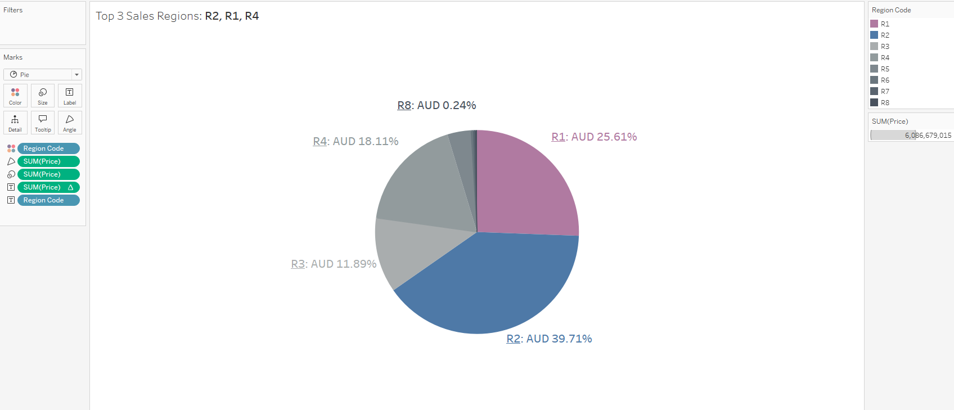

Findings:
This pie chart shows, Top 3 regions contributing major sales transactions in Melbourne.
From the visualization, we can do analysis on these regions.
- R2 - Southern Metropolitan
- R1 - Northern Metropolitan
- R4 - Western Metropolitan

2.Side by Side Bar chart: To visualize comparison of housing types and sales amount in Top 3 regions.
Fields used:
Categorical – Region Code, Type
Dimension - Price

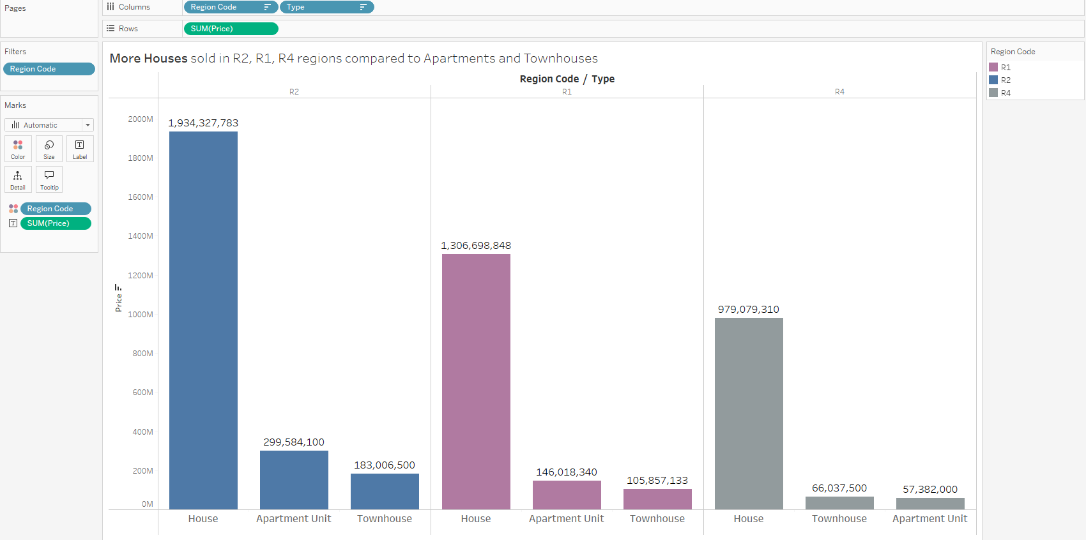
Findings:
Bar chart shows, comparison of 3 housing types (House, Apartment Unit, Townhouse) and sales in the R2, R1, R4 regions.
- House – Most popular among the three house types
- Apartment Unit
- Townhouse

3.Trend chart 1: Combination of Bar chart and Line chart
To visualize sales transaction trend over the period of 2016, 2017, and 2018.
Monthly sales amount is plotted and combined with line chart to see the growth variation in each month.
Average value is included to identify any outlier and/or interesting pattern in sales trends during the analysis period.
Fields:
Categorical – Date( Year , Month part)
Dimension - Price

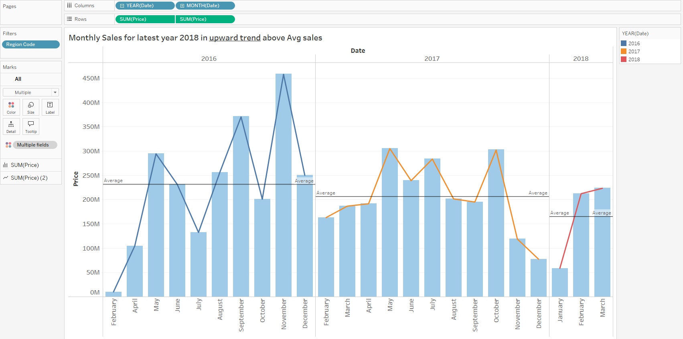

Findings
- Year 2016 – upward trends above Average sales. Market fluctuation is more, reaching peak and low sales frequently.
- Year 2017 – trends below Average sales. But transactions are consistent in most of the months.
- Year 2018 – upward trend above average sales.
- Both 2016 and 2017 year May Month sales consistently above average.

4.Trend chart 2: Combination of Bar chart and Line chart
To visualize regional sales transaction trend for the latest year 2018
Monthly sales( Jan , Feb , March only as per latest year data) amount is plotted and combined with line chart to see the growth variation in each month in each Top 3 regions as with reference we have found in earlier Pie-chart.
Fields:
Categorical – Date( Year , Month part), Region Code
Dimension - Price
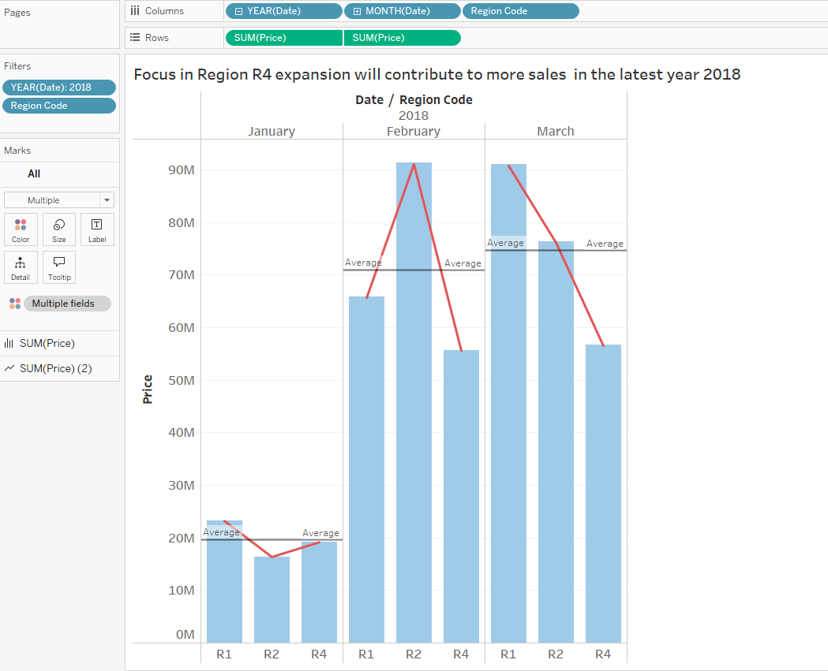
Findings:
- Region R1- upward trend above average sales, though slightly below average sales in Feb.
- Region R2 – upward trend above average sales.
- Region R4 – is consistent, but below average sales throughout 3 months.

Summary of Analysis and insights:
For the expansion of Melbourne real estate project.
- Developments on Regions R2, R1, R4 will be more beneficial, as those are Top 3 contributors to Total sales.
- Housing type – House model is more popular.
- It is important to expand on Region R4 as being one of top 3 regions in sales, current sales trend shows below average sales.

